**Applicazioni per Dispositivi Mobili**

**A.A. 2021/2022**

**NFT- SHOP**

**Design documentation**

|  |  |  |
| --- | --- | --- |
| **Team Members** | | |
| **Name** | **Student Number** | **E-mail address** |
| Alessandro Di Benedetto | *265181* | alessandro.dibenedetto1@student.univaq.it |
| Pietro Pisegna | *265589* | pietro.pisegna@student.univaq.it |

Strategy

# Product Objectives

# Business goals

The Application’s purpose is to provide a commercial environment among NFT picture artists all over the world.

# Product Overview

NFT–SHOP is an APP that helps people & NFT artists to sell and buy NFT pictures, providing a stable platform and showroom to make themselves a name in the artistic business. This APP aims to be usable by a vast diversified audience, from expert artists to beginners and public / collectors.

# Competitors

Crypto.com: one of the first marketplace of NFT ARTs. It is an online platform providing multiple features, including NFT pictures. Its main issue is that it doesn’t provide a user-friendly environment to grow artists’ drawing skills.

**User Needs**

**Needs & goals**

We want the emerging artist to gain visibility, grow its business and skills, meanwhile expand their collection. We provide users with easy-to-use platform, a common marketplace, and a personal storage to save own NFTs; all done in few taps.

# User Research

A typical user session for this application has a medium-long period of activity because the user spends time searching, buying, and building his own NFT picture collection.

All features will be probably used in situations where the user isn’t in a hurry, and he is focused on the app usage.

# Personas

|  |
| --- |
| **Nickname:** Lukezoff1 |
| **Level of skill:** amateur |
| **Description:** I am an amateur of the art world. I want to try drawing pictures. |

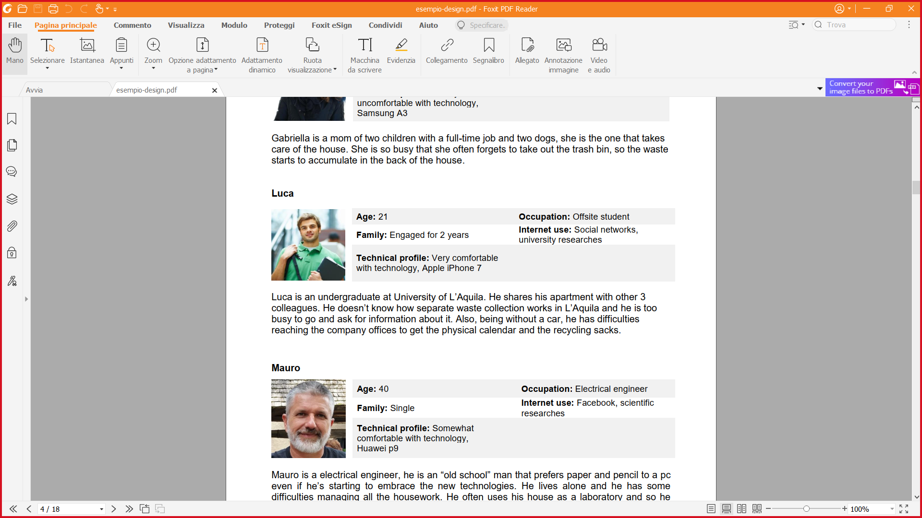

|  |
| --- |
| **Nickname:** Maurius324 |
| **Level of skill:** professional |
| **Description:** I love drawing since I was a child and I like collecting NFT pictures too. I’m now an expert of the environment but I’m not known a lot. I’m unemployed right now. |

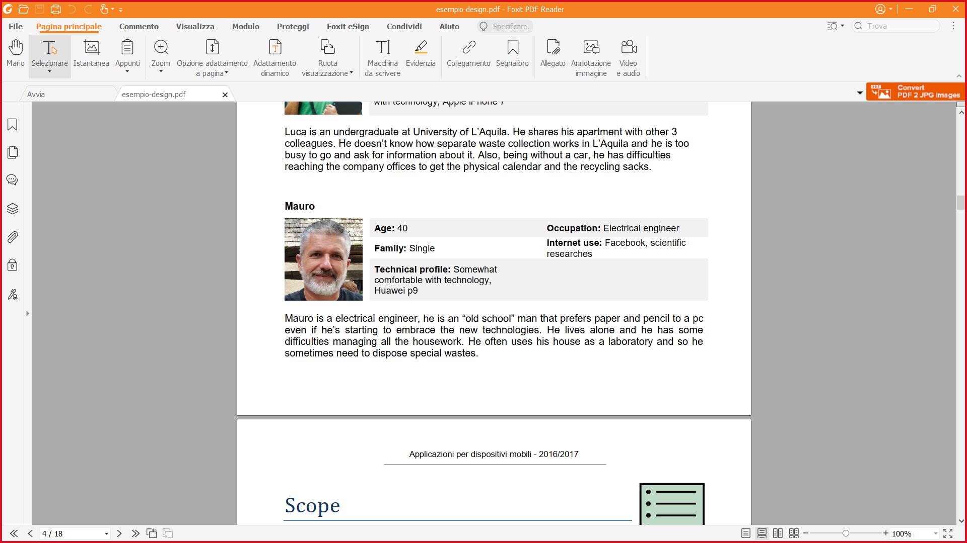

|  |
| --- |
| **Nickname:** Gabry65 |
| **Level of skill:** amateur |
| **Description:** I’m not an artist and I can’t draw but I love collecting pictures representing landscapes. I’m a great collector. |

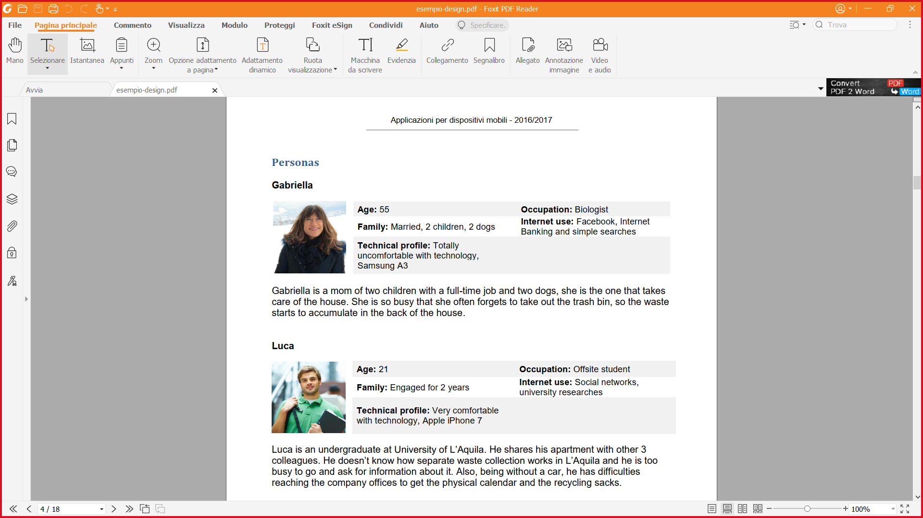

Scope

**Features**

* The application allows the user to **CREATE** a personal buyer-seller profile with only one action.
* The application provides users with an internal **MARKETPLACE** that permits users to buy/sell NFTs of their liking.
* Every user will be provided with a personal **STORAGE** to use as a **GALLERY** of NFTs.
* **LOGIN/LOGOUT.**
* Every user has the possibility to **ADD** NFTs in their gallery from external sources.
* Every user has the possibility to **DELETE** ownedNFTs only from their gallery.
* The application has its own **INTERNAL CURRENCY** (CASHART) to manage transactions. Every user will be provided with a fixed amount of CASHART at the first access.

**Other requirements**

* **SHOP WINDOW** common to all users where will be shown the last six added NFTs on the market.
* The user has the possibility to switch between **PERSONAL/PUBLIC COLLECTION** with the benefit of choosing which NFTs will be shown to other users when scrolling their profile.
* **NOTIFY** the user when the picture is sold with a summary of the transaction.
* The application **DOES NOT** permit users to create NFTs within the APP, because the app is not provided with an own editor nor linked to external editors.
* The user is provided with a **SEARCH** function. He can search between artist profiles and NFTs on sale.
* The application provides a brief **SUMMARY** of the last NFTs sold and bought in the private profile section for the user.
* The application shows a brief **SUMMARY** of the user’s on-sale NFTs in the public profile section.
* The application provides a **DETAIL PAGE** for each NFTs.

**Scenarios**



Luca is passionate of the art. He discovers the existence of NFT pictures, and he falls in love with the idea of drawing pictures himself. He has great ideas and a lot of spare time, but he is a beginner, so he wants to gain skills and improve his drawings. One day, his friend told him about NFT-SHOP, a great application for amateurs and professionals of the drawings. He thinks of using this app to improve his skills inspired by the works of other artists.



Mauro is a professional drawing artist. He has worked for a local newspaper as a cartoonist for 8 years. Recently the company’s financial broke and he became unemployed. He wants to continue his drawing career, so he started searching for a job. Eventually he got suggested, by his online research, of an app: NFT-SHOP. He decides to try it and started to post his artwork having a lot of success at that too. He became famous in a short time and eventually he got employed by a successful cinematographic company.



Gabriella is a famous art collector. She needs a digital platform to store and publicize her physical art collection. She wants also to know more about digital art and NFT artists, so she can expand her collection. After a brief research on the Internet, she discovers a perfect application that satisfies her needs: NFT-SHOP, the perfect app to store a personal collection in a safe place, share it with all the users and to discover new art talents.

Structure

# Navigation model



**Splash Screen:**

This is the opening view of NFT_SHOP. The user will see this view when he starts the app.

**Login:**

This is the login page, the user needs to login to use the app, if he put wrong credentials, he needs to login again.

**Register:**

This is the registration page, If the user is new, he needs to register first prior login in the app.

**Persistent tool bar:**

This is a tool bar that contains the icon of the hidden menu, the app name at the center and the internal currency of the current user which is given for free in 1000 units for the first login to start the adventure.

**Home:**

This is the main page of the app after the login, this house the shop window which contains the last 6 NFT items added, the button to navigate to the complete NFT shop and a footer that contains the creators’ nicknames.

**Hidden Menu:**

This view is the hidden menu, it’s always present during the app usage in all section, it can be accessed in all sections, it is a fast navigation tool, it is a showable list thanks to an icon on the upper left corner; here the user can choose to go in Profile, Gallery, Notifications sections and to Log Out the app.

**Notifications:**

This is the view where the notifications about items state are shown, when a item is sold it will be displayed here with all details.

**Gallery:**

This is the view of the user gallery, here he can find all possessed items with the possibility to add a new NFT items made with an external editor or hand draw, he also has the possibility to show some or all his NFT items with a switch or by holding a single item and tapping on whatever he wants to make public.

**New NFT item:**

Here the user can add his own NFT by loading the NFT picture and inserting all details and pressing the ADD button.

**Not On Sale NFT Item**:

This is the NFT item detail page where the user can find all its details with the button to sell the item.

**Sell NFT Item:**

Here the user can decide what price he want to sell for the NFT Item after he sold the item, he will be redirected to the home and the item will be added to the shop window and whole market.

**Shop:**

This is the complete shop where the user can find all NFT items in sale, the items are ordered by date, but he can order them by other criteria in the little select at the upper right corner, he can also access the search utility by clicking on its button.

**Search:**

This is the view where the user can search between NFT items and Users by selecting it on a select on the upper right corner, when the user selects the type of research, he wants to do he can type the name and press enter or the search button, each result is clickable and can take the user to its own page.

**On Sale NFT Item**:

This is the detail page of each NFT item in the shop, it shows all details and price, and the user can buy it with the Buy button only if he can afford it or go back to the shop with the go back button, there are also present the Seller and Author buttons to go directly to their pages.

**Profile**:

This is the page of the user profile that contains all of his info and two sections, one for the private side where he can find a brief history of his last bought and last sold items and the second for the public session where he can find a bunch of his public gallery items and his last on sale items all of those sections have a button to go directly to the own page.

**Public Section**:

**Public Gallery Not on Sale Item:**

Here is a detail page of the public item like the private gallery.

**On sale NFT items:**

This is the internal store page of the user where he can find all his on-sale item, each item will take the user to the detail page by clicking on it.

**Private Section**:

**Purchased NFT items History**:

This the history of user all purchased items with a brief list of transaction details.

**Sold NFT items History:**

This the history of user all sold items with a brief list of transaction details.

Each History has a single page connected to show all transaction and NFT item sold/bought.

# Data model

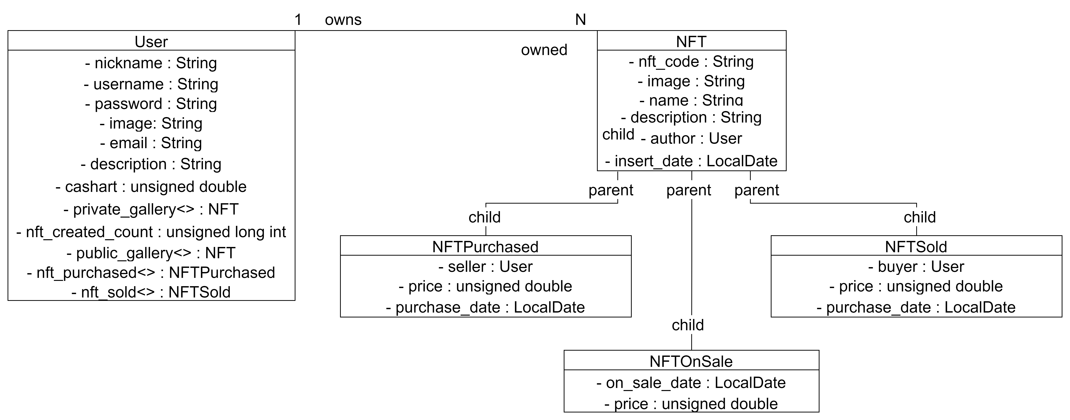

**User**:

The User entity represents the users with their basic information, with included the private gallery and public gallery that can contain the same items or less as the private one, no need to delete an item from one of those to display publicly.

The entity also contains the array list of sold and purchased items.

**NFT**:

This is the entity for representing an NFT picture, all its details as a non-sellable item.

**NFTOnSale**:

This is the entity that extends NFT which is used to sort and handle all items on sale which are taken out of the private and public gallery when are in sale with all their details.

**NFTSold**:

This entity represents the single item that has been sold to keep track of all sold items.

**NFTPurchased**:

This entity represents the single item that has been purchased to keep track of all purchased items.

Skeleton

REMOVE THE DESCRIPTION

Lo-Fi Wireframes of your app. In this phase you have to create a **complete wireframe** representing all the views described in the navigation model.

Also, for each LO-FI wireframe give a brief description and highlight the design principles used and the design patterns.

Surface

REMOVE THE DESCRIPTION

Description of the relevant choices you made about the layout and color palette, fonts, icons, etc.

Provide a Hi-Fi Wireframes of a **single (or two) view** of your app. Please choose a representative view to show here.